

School of InfoComm Technology

Data Discovery & Visualisation
Diploma in Data Science
Diploma in Information Technology
October 2024 Semester

ASSIGNMENT 1
(Individual Assignment)

Submission Deadline:
06 December 2024 (Friday), 2359 hrs.

Tutorial Group | : | P01
Student Name | : | Natalie wong
Student Number | : | S10257861
Video Link | :

Penalty for late submission:
10% of the marks will be deducted every calendar day after the deadline.
NO submission will be accepted after 13 December(Friday), 2359 hrs.

Table Of Contents

- Introduction……..…………………………………………………………………………..3

- Data Preperation……………………………………………………………………………4

- Visualisations………………………………………………….........................................9

- Dashboard……………………………………………………………………...……..……20

- Conclusion………………...………………………………………………………..……..21

- Introduction

My assignment involves the design and implementation of four interactive dashboard using Tableau Desktop, aimed at exploring datasets associated with the palm oil industry. SawitPRO’s mission is to revolutionize the palm oil industry by enhancing productivity, sustainability, and collaboration among stakeholders in the palm oil supply chain therefore, through this assignment, I will clean, prepare, and analyze the data to generate insightful visualizations and dashboards that support SawitPRO’s business objectives. By addressing all my exploratory question, I aim to provide valuable insights for SawitPRO to improve decision-making, optimize operations, and identify growth opportunities within the palm oil industry.

- Exploratory Questions

- Dsp_order_dataset:

- What is the total number of products sold for each product category?
- What is the order cancellation rate by product category?
- Which city store city has the lower sales volume?

- User_activity dataset:

- What is the distribution of user activity across different regions?
- Which time of the day (UTC +7) has the highest user activity?

- Palm_oil_production dataset:

- What is the country with the highest palm oil prodution?
- How have countries with the largest palm oil export volume changed over time?
- How do export volumes vary between top exporting countries?
- What are the peak years for palm oil exports in major markets?

- Vegetable_oil_production dataset:

- What is the production of different vegetable oils in major export regions?

Biofuel_production dataset:

- Which countries are the largest producers of biofuel, and how does their palm oil production compare?
- How does biofuel production influence the export volumes of palm oil in major producing countries?

- Data Preperation

- The two data sources that were provided to us in CSV format required quite a bit of cleaning to transform the data and make it suitable for accurate analysis. However, the three self-sourced data sources which were also downloaded in CSV format only required minimal cleaning as most of the data were already suitable for analysis.

- Dsp_order data source:

Dataset File Structure: The file currently contains a total of 4480 rows and 20 columns. According to the metadata provided with the assignment, the columns are listed below.

Column# | Column | Description | Remarks and Data Transformation Done
1. | User_id | Unique id for each user. | Checked and verified to make sure there are no duplicate user_ids.
2. | User_location_city | City where user is located. | Some columns contained null values, therefore, I deleted the rows with null values in this column.
3. | User_location_region | Region where user is located. | No data cleaning needed.
4. | Store_id | Unique id for each store. | Checked and verified to make sure that there are only two different store_id in this column
5. | Product_id | Unique id for each product. | No data cleaning needed.
6. | Product_category | The category to which the product belongs to, | No data cleaning needed.
7. | Product_quantity | The number of products ordered by the user. | No data cleaning needed.
8. | Store_city | City at which the store is located. | Checked and make sure that there are only two different store_city that were listed in this column
9. | Store_region | Region at which the store is located | No data cleaning needed.
10. | Store_open_hour | Represents the store’s closing hour. | No data cleaning needed.
11. | Store_close_hour | Represents the store’s closing hour. | No data cleaning needed.
12. | Order_status | Represents the order status of each order. | No data cleaning needed.
13. | Order_at_utc0 | represents a timestamp in epoch (or Unix) time format, specifically adjusted to the UTC+7 time zone for the time of order. | No data cleaning needed.
14. | Order_at_utc7 | represents a timestamp in epoch (or Unix) time format, specifically adjusted to the UTC+7 time zone for the time of order. | Manually added this column to ensure that the timing was converted from utc0 to utc7.
15. | Paid_at_utc0 | represents a timestamp in epoch (or Unix) time format, specifically adjusted to the UTC+0 time zone for the time of payment. | No data cleaning needed.
16. | Paid_at_utc7_date | represents a datestamp in epoch (or Unix) time format, specifically adjusted to the UTC+7 time zone for the time of payment. | Manually added this column to separate the date and time stamps to make adding them as fields in tableau easier. I then converted these datestamps from utc0 to utc7 and converted them from strings to human-readable format by formatting them to date.
17. | Paid_at_utc7_time | represents a timestamp in epoch (or Unix) time format, specifically adjusted to the UTC+7 time zone for the time of payment. | Manually added this column to separate the date and time stamps to make adding them as fields in tableau easier. I then converted these timestamps from utc0 to utc7 and converted them from strings to human-readable format by formatting them to date.
18. | Completed_at_utc0 | represents a timestamp in epoch (or Unix) time format, specifically adjusted to the UTC+0 time zone for the completion of payment. | No data cleaning needed
19. | Completed_at_utc7_date | represents a datestamp in epoch (or Unix) time format, specifically adjusted to the UTC+7 time zone for the completion of payment. | Manually added this column to separate the date and time stamps to make adding them as fields in tableau easier. I then converted these timestamps from utc0 to utc7 and converted them from strings to human-readable format by formatting them to date.
20. | Completed_at_utc7_time | represents a timestamp in epoch (or Unix) time format, specifically adjusted to the UTC+7 time zone for the completion of payment. | Manually added this column to separate the date and time stamps to make adding them as fields in tableau easier. I then converted these timestamps from utc0 to utc7 and converted them from strings to human-readable format by formatting them to date.

- User_activity data source:

Dataset File Structure: The file currently contains a total of 36837 rows and 10 columns. According to the metadata provided with the assignment, the columns are listed below.

Column # | Column | Description | Remarks and Data Transformation Done
1. | epoch_activity_timestamp_utc7 | represents a timestamp in epoch (or Unix) time format, specifically adjusted to the UTC+7 time zone. | Converted these timestamps to human-readable format by formatting it to time.
2. | epoch_activity_datestamp_utc7 | represents a datestamp recorded in the epoch (or Unix) time format but adjusted for the UTC+7 time zone. | Manually added this column to separate the date and time stamps to make adding them as fields in tableau easier. I then converted these timestamps to human-readable format by formatting it to date.
3. | user_id | Unique id for each user | Checked and verified to make sure there are no duplicate user_ids.
4. | city | City where each user is from | No data cleaning required.
5. | region | Region where each user is from | No data cleaning required.
6. | country | Country where each user is from | No data cleaning required.
7. | sub_continent | Sub continent where each user is from | No data cleaning required.
8. | continent | Continent where user is from | No data cleaning required.
.9. | user_activity | represents the type of actions or tasks users perform within a system or application. | No data cleaning required.

- Palm_oil_production data source:

Dataset File Structure: The file currently contains a total of 4746 rows and 4 columns. According to the metadata provided with the assignment, the columns are listed below.

Column# | Column | Description | Remarks and Data Transformation Done
1. | Entity | Country of production | No data cleaning needed.
2. | Code | A short form used for the country | No data cleaning needed.
3. | Year | The year of production | String instead of numeric.
4. | Palm oil Production / tonnes | The amount of palm oil produced in tonnes. | No data cleaning needed.

- Vegetable_oil_production data source:

Dataset File Structure: The file currently contains a total of 13097 rows and 16 columns. According to the metadata provided with the assignment, the columns are listed below.

Column# | Column | Description | Remarks and Data Transformation Done
1. | Entity | Country of production | No data cleaning needed.
2. | Code | A short form used for the country | No data cleaning needed.
3. | Year | The year of production | String instead of numeric.
4. | Oil of sesame seed | 00000290 || Production | 005510 || Tonnes | The amount of oil of sesame seed produced in tonnes. | No data cleaning needed.
5. | Maize oil | 00000060 || Production | 005510 || tonnes | The amount of maize oil produced in tonnes. | No data cleaning needed.
6. | Safflower-seed oil, crude | 00000281 || Production | 005510 || Tonnes | The amount of sunflower-seed oil produced in tonnes. | No data cleaning needed.
7. | Coconut oil | 00000252 || Production | 005510 || tonnes | The amount of coconutoil produced in tonnes. | No data cleaning needed.
8. | Sunflower-seed oil, crude | 00000268 || Production | 005510 || Tonnes | The amount of sunflower-seedoil produced in tonnes. | No data cleaning needed.
9. | Rapeseed or canola oil, crude | 00000271 || Production | 005510 || Tonnes6 | The amount of rapeseed oil produced in tonnes. | No data cleaning needed.
10. | Palm kernel oil | 00000258 || Production | 005510 || tonnes | The amount of palm kernel oil produced in tonnes. | No data cleaning needed.
11. | Groundnut oil | 00000244 || Production | 005510 || tonnes | The amount of groundnut oil produced in tonnes. | No data cleaning needed.
12. | Linseed oil | 00000334 || Production | 005510 || tonnes | The amount of linseed oil produced in tonnes. | No data cleaning needed.
13. | Olive oil | 00000261 || Production | 005510 || tonnes | The amount of oliveoil produced in tonnes. | No data cleaning needed.
14. | Palm oil | 00000257 || Production | 005510 || tonnes | The amount of palm oil produced in tonnes. | No data cleaning needed.
15. | Soya bean oil | 00000237 || Production | 005510 || Tonnes | The amount of soya bean oil produced in tonnes. | No data cleaning needed.
16. | Cottonseed oil | 00000331 || Production | 005510 || tonnes | The amount of cottonseed oil produced in tonnes. | No data cleaning needed.

- Biofuel_production data source:

Dataset File Structure: The file currently contains a total of 1178 rows and 5 columns. According to the metadata provided with the assignment, the columns are listed below.

Column# | Column | Description | Remarks and Data Transformation Done
1. | Entity | Country of production | No data cleaning needed.
2. | Code | A short form used for the country | No data cleaning needed.
3. | Year | The year of production | String instead of numeric.
4. | Biofuels production - TWh | The amount of biofuel produced in TWH | No data cleaning needed.
5. | Biofuels production - tonnes | The amount of biofuel produced in tonnes | Manually added this column to convert the amount of biofuel in TWH to tonnes so as to ensure accurate analysis when adding this to the fields in tableau.

- Data Types: Scanned through all the columns for each dataset in the Tableau data source tab to ensure that all the columns were assigned to their correct data types and corrected them when necessary (etc Geographic data or date fields converted from string or number to date).

- Transformation of timestamps to usable formats: Converted columns with epoch time into a readable data-time format by formatting them in Excel. Additional date-related fields were then created to extract the date and time seperately from the time stamp.

- Standardising data: Ensured that all numerical columns were in the same unit of measurement. For columns with different measurements from the majority measurement, conversion is done to ensure a standardize measurement across all datasets to ensure accurate analysis (etc convertion of twH to tonnes).

- Creating new calculated fields: There were some datsets that lacked fields needed for analysis therefore, new formulas were made to derive new fields to fill in certain gaps to answer certain exploratory questions (etc cancellation rate field).

- In addition to reading and understanding the read-me file for each of the datasets, I performed further research on the metadata and data so as to better understand the context of each dataset. Although the readme description for the provided datasets offered guidance for its exploratory questions as well as a rough description of the dataset, I still had to self-source other relevant datasets to develop more exploratory questions. I wanted to ensure that the datasets I sourced aligned with business goals and user requirements therefore, before choosing my dataset, it was important that I manually inspect each field to identify its purpose, data type, and any calculated fields when creating the dataset as well as ensure the reliability of the data. This helps in understanding how data is represented and how fields relate to each other, creating proper analysis. Lastly, after narrowing the potential datasets I would use, I researched the palm oil industry and the external factors that would pertain to my analysis such as market trends, as well as studying major palm oil producers and certain trends associated with t3hem. By doing so, I will be able to interpret my findings more accurately and ensure that my analysis is aligned with real-world dynamics, particularly when dealing with complex or specialized fields like palm oil production and biofuel. These research findings help interpret visualisations by providing context behind certain patterns and trends and identify the external variables that cause the visualization to turn out a certain way (etc market trends and policies).

- Data visualizations

- What is the total number of products sold in each product category?

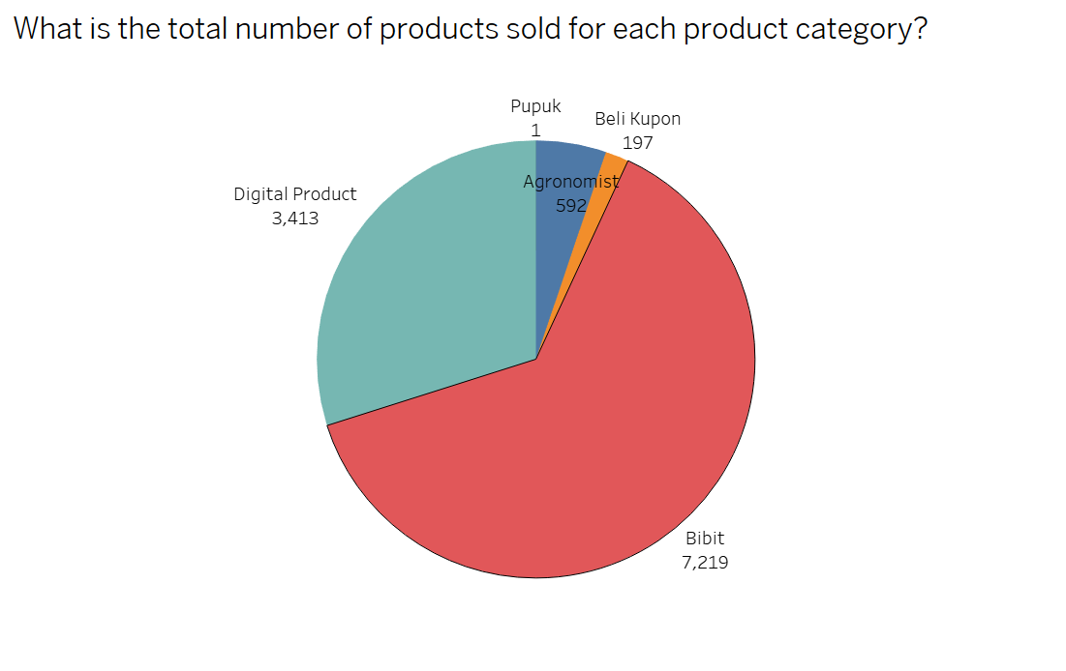
Overview of the dataset:
Chart Type: Pie chart
Fields Used: Product Category, Product Quantity
Colour Encoding: Each product category is represented by one unique colour

Insights:
From this visualization, we can infer that the most popular product category is Bibit, with 7,219 products sold, followed by Digital Products, with 3,414 products sold. The red portion of the pie chart representing Bibit occupies slightly more than two-thirds of the chart, while the teal portion representing Digital Products covers almost one-third. The remaining segments of the pie chart represent Agronomist (blue), Beli Kupon (orange), and Pupuk, which is shown as a thin line due to its minimal contribution. Among these, Pupuk is the least popular category, with only one product sold, as indicated by its negligible space on the pie chart.

How it helps SawitPRO and recommendations:
By analysing the total number of products sold in each product category, SawitPRO can identify top-performing product categories and focus on promoting and scaling these categories further. This helps allocate resources efficiently to maximize revenue and customer satisfaction. In this case, SawitPRO can consider investing more in marketing and distribution for this category. On top of identifying top-performing products, this visualization also helps identify underperforming product categories, which in this case, is Pupuk. This allows SawitPRO to investigate potential issues (etc, lack of demand or pricing challenges) and they can then decide whether to re-strategize or phase out underperforming products. Lastly, this visualization can also ultimately strengthen stakeholder relationships. These insights into product sales provide data-backed evidence to engage stakeholders, such as suppliers or distributors, and demonstrate the platform's success in driving sales, especially for their top performing categories like Bibit and Digital Products, leading to better partnerships and support for future growth.

- What is the order cancellation rate by category?

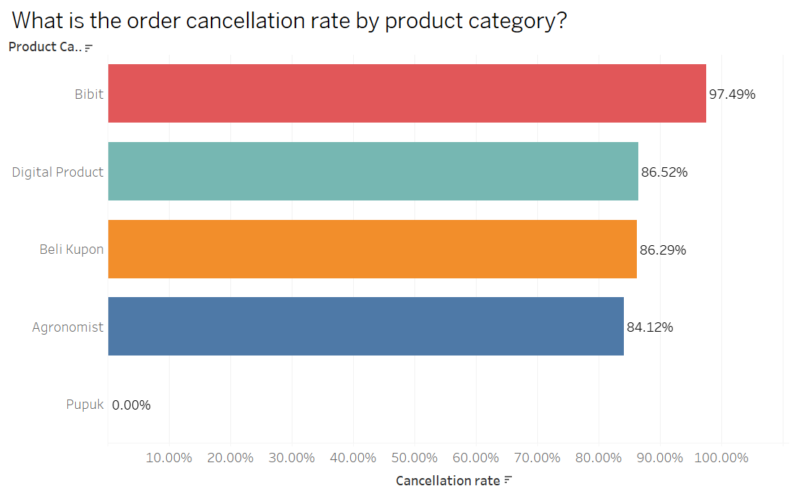
Overview of the dataset:
Chart Type: Bar chart
Fields Used: Product Category, Cancellation Rate (Created Field)
Colour Encoding: Each product category is represented by one unique colour
Created Fields used: Cancelled order (IF [Order Status] = "CANCELLED" THEN 1 ELSE 0 END), Cancellation rate (SUM([Canceled orders]) / SUM([Total Orders])

Insights:
From this visualization, we can infer that the product category with the highest cancellation rate is Bibit, with a cancellation rate of 97.49%, as indicated by the red bar. This is then5 followed by Digital Products, with a cancellation rate of 86.52%, represented by the teal bar. Similarly, Beli Kupon (orange bar) and Agronomist (blue bar) exhibit comparable cancellation rates of 86.29% and 84.12%, respectively.
Among the five product categories, Pupuk has the lowest cancellation rate of 0%. This trend aligns with the previous dataset, where cancellation rates appear to correlate with the total number of products sold in each category. Specifically, categories with higher sales volumes tend to have higher cancellation rates. In contrast, Pupuk has a cancellation rate of 0% because no products were sold in this category.

How it helps SawitPRO and recommendations:
By analysing the order cancellation rate by category, SawitPRO can identify underlying issues such as misleading product descriptions, poor quality products or inefficient delivery times. This would in turn benefit the company’s stakeholders by enabling targeted improvements in the problematic product categories to reduce further cancellations in the future and directly increase completed sales, driving revenue growth.

- Which store city has the lowest sales volumes?

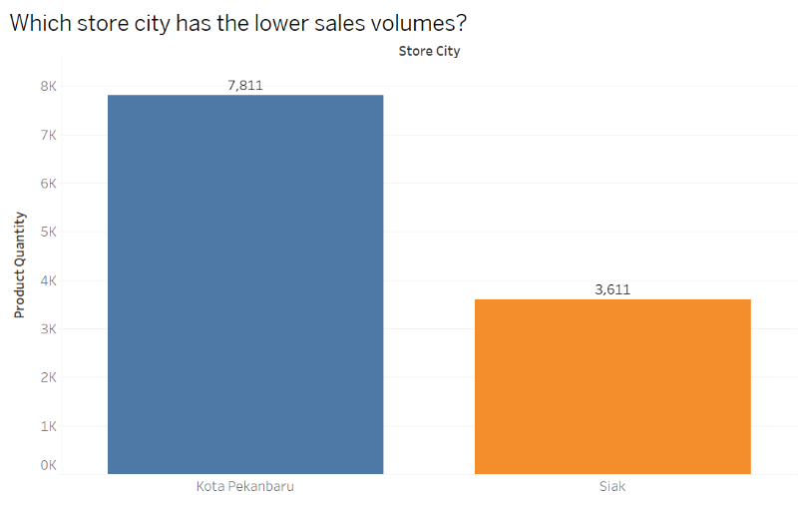
Overview of the dataset:
Chart Type: Bar Chart
Fields Used: Product Quantity, Store city
Colour Encoding: Each store city is represented by one unique colour

Insights:
From this visualization, we can infer that the store in Siak has the lowest sales volume, with only 3,611 products sold. This is 4,200 fewer products compared to the store in Kota Pekanbaru, as reflected by the height difference between the blue bar representing Kota Pekanbaru and the orange bar representing Siak.

How it helps SawitPRO and recommendations:
By analysing the store city with the lower sales volume out of the two locations, SawitPRO can pinpoint cities where sales are consistently low, indicating potential issues such as low demand, poor visibility, or logistical challenges. Low sales volumes may highlight mismatches between customer needs and available products or services in specific locations. Therefore, this information encourages stakeholders to revisit product assortments or services offered in underperforming cities to align with local preferences to improve customer satisfaction and sales performances in the location.

- What is the distribution of user activity across different regions?

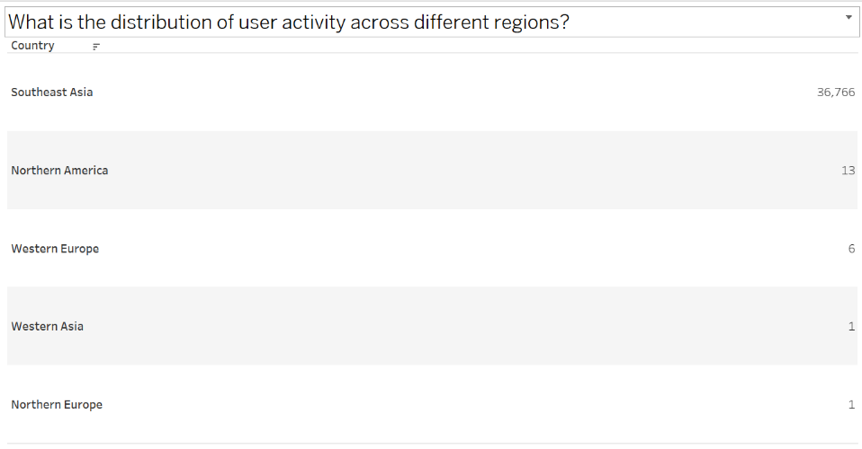
Overview of the dataset:
Chart Type: Text tables
Fields Used: Region, user activity

Insights:
From this visualization, SawitPRO can infer that the majority of user activity is concentrated in Southeast Asia, with 36,766 activities recorded, indicating that this region is the most engaged with the platform. In contrast, user activity in Northern America is significantly lower, with only 13 activities, while Western Europe follows with just 6 activities. User activity in Western Asia and Northern Europe is minimal, with only 1 activity recorded in each region. This suggests that SawitPRO's user base is predominantly centered in Southeast Asia, and there may be limited engagement or awareness of the platform in other regions.

How it helps SawitPRO and recommendations:
By analysing the distribution of user activity across different regions, SawitPRO can identify key markets and regions for further growth. Understanding where majority of the user activity occurs (Southeast Asia) allows SawitPRO to identify regions with high engagement. This insight helps them focus their efforts on areas that show the greatest potential for growth. This can be through prioritising marketing, partnerships, and expansion efforts in high-activity regions, ensuring resource allocation is aligned with areas showing the most promise. Furthermore, SawitPRO can also optimize regional marketing strategies by recognizing the distribution of activity across regions. SawitPRO can tailor its marketing strategies to specific regions. For instance, since Southeast Asia has the highest user activity, campaigns can be designed to deepen engagement with existing users, while the rest of the regions with potential to increase user activity, such as Northern America and Western Europe with significantly lower activity compared to Southeast Asia can be targeted with promotional efforts. Therefore, stakeholders can make data-driven decisions about regional outreach, potentially increasing user acquisition and retention rates in these underperforming regions.

- Which time of the day (UTC+7) has the highest user activity?

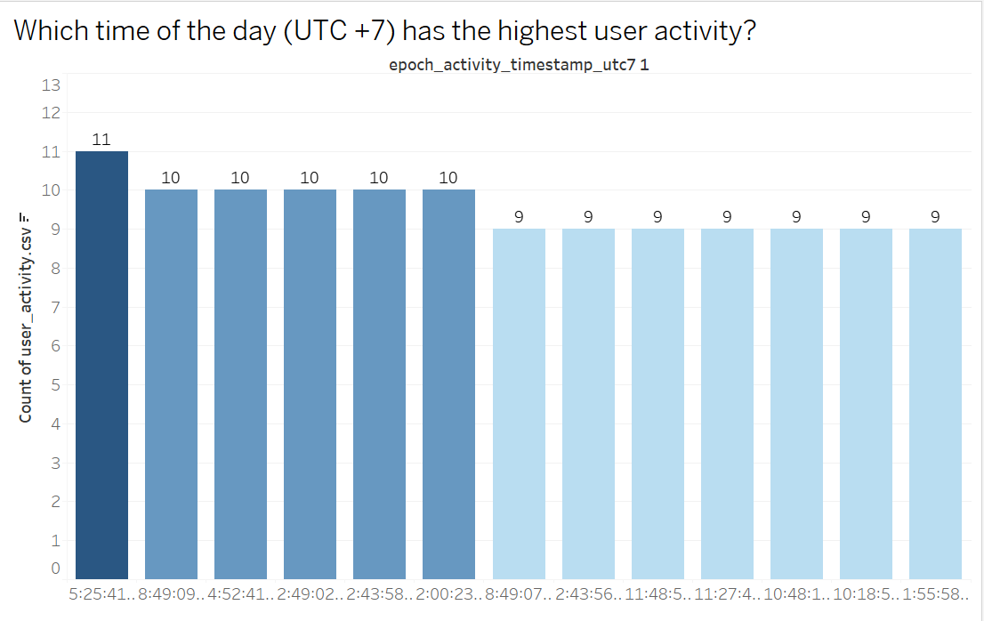
Overview of the dataset:
Chart Type: Bar Chart
Fields Used: epoch_activity_timestamp_utc7, user_activity, country(filter)
Colour Encoding: The number of users active is represented by one unique colour

Insights:
From this visualisation, we can infer that the time of the day (UTC+7) that has the highest user activity is at 5.25pm, with 11 active users at that time. This is then followed by 8.49pm, 4.52pm, 2.43pm,2.49pm and 2pm, with 10 active users at each of the respective timings. This shows that the timings with the highest number of active users mostly occur in the afternoon.

How it helps SawitPRO and recommendations:
By analyzing the times of the day with the highest user activity, SawitPRO can identify the times of day when user activity peaks, allowing optimization of engagement strategies. For instance, since the highest activity occur between 2.40pm and 3pm and between 4.50pm and 5.30pm, SawitPRO can schedule marketing campaigns, product launches, or notifications to coincide with these peak times. By doing so, stakeholders can leverage this insight to maximize the effectiveness of their outreach efforts, ensuring that communications or promotions reach users when they are most active, increasing engagement and conversion rates. Furthermore, with the understanding of peak user activity, SawitPRO can also improve customer availability support by understanding when users are most active helps SawitPRO ensure that customer support teams are available during peak hours to handle inquiries, resolve issues, and assist users in real-time. By doing so, stakeholders in customer support and operations can allocate resources effectively, ensuring that they are staffed appropriately during periods of high user activity, thus enhancing the overall user experience.

- What is the country with the highest palm oil prodution?

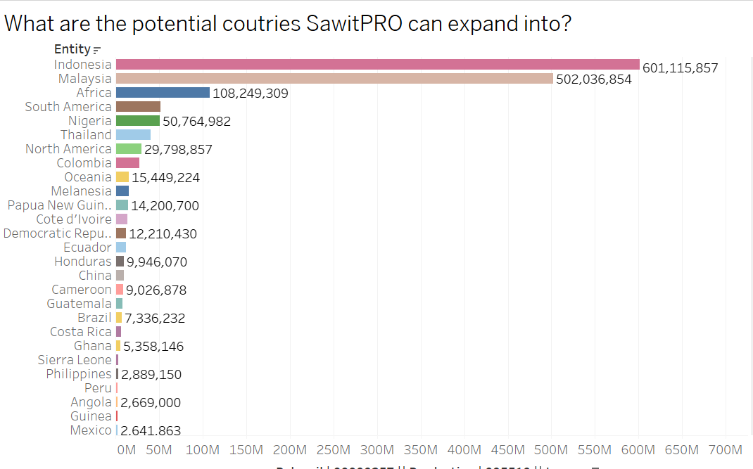

Overview of the dataset:
Chart Type: Bar Chart
Fields Used: Country, Palm oil | 00000257 || Production | 005510 || tonnes
Colour Encoding: Each country is represented by one unique colour

Insights:
From this visualization, we can infer that the country with the highest palm oil production is Indonesia, with a total of 601,115,857 tonnes of palm oil being produced since they first started production. Following that, Malaysia has the second highest production of Palm Oil, with a total of 502,036,852 tonnes of palm oil being produced since they first started production.

How it helps SawitPRO and recommendations:
By analyzing the country with the highest palm oil production, we can help SawitPRO determine potential expansion opportunities. As SawitPRO is already based in Indonesia, we can consider Malaysia as the country with the most potential for possible expansion, particularly given that Malaysia is the second-highest country in terms of palm oil production. Since Malaysia is one of the world's largest producers and exporters of palm oil, second only to Indonesia. This directly aligns with SawitPRO’s mission to innovate and improve the palm oil industry. SawitPRO is already focused on the palm oil sector in Indonesia, Malaysia’s strong presence in the industry means that they are likely to have similar industry needs, such as efficiency improvements, sustainability initiatives, and better connectivity between mills, agents, and smallholders. This creates a natural opportunity for SawitPRO to expand its offerings in Malaysia, leveraging its existing expertise. Furthermore, expanding to Malaysia would also allow SawitPRO to tap into a well-established and significant market that is integral to their business focus. As both countries predominantly speak Malay and Indonesian, communication barriers are minimal. This common linguistic base makes it easier for SawitPRO to market its services, provide customer support, and build relationships with stakeholders in both countries without the need for extensive language localization.

- How have countries with the largest palm oil export volume changed over time?

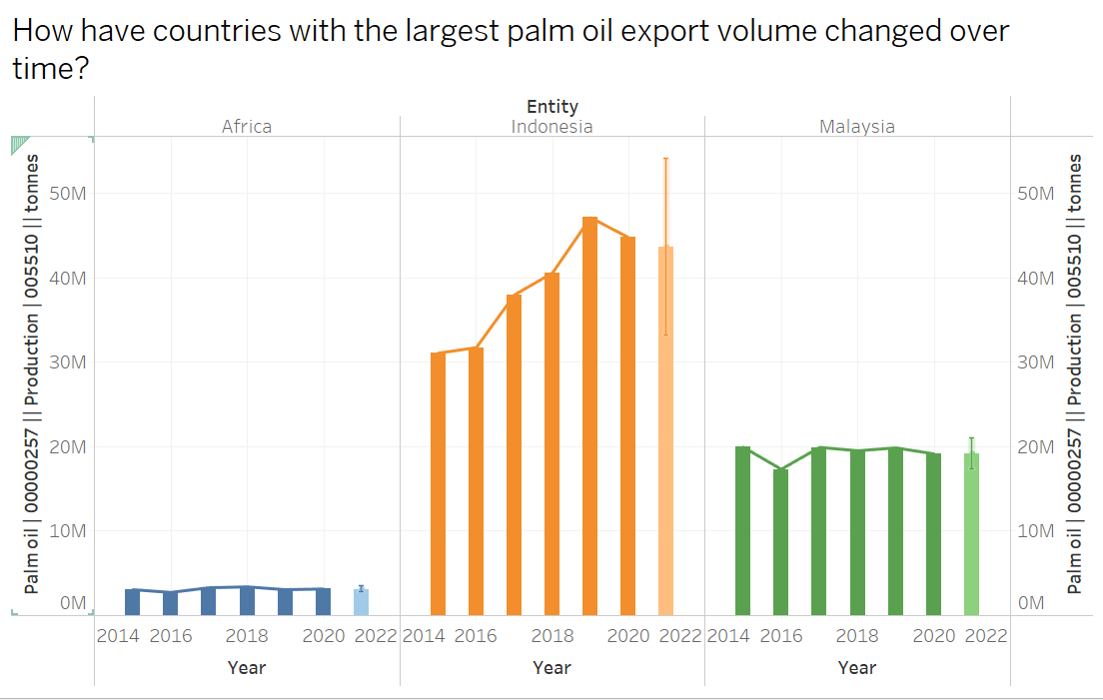

Overview of the dataset:
Chart Type: Dual axis bar and line Chart
Fields Used: Country, Year, Palm oil | 00000257 || Production | 005510 || tonnes
Colour Encoding: Each country is represented by one unique colour

Insights:
From this visualization, we can infer that Indonesia and Malaysia have consistently been the top two producers and exporters of palm oil. The orange bar charts representing Indonesia has seen a significant increase in production and export volume over the years, especially from the years 2015-2019, with 2019 producing the highest amount of palm oil (approximately 48M tonnes) before experiencing a decrease from 2019-2021. Similarly, the green bar charts representing Malaysia have also increased its production, but at a slower rate compared to Indonesia, with fluctuations seen from 2016-2020. However, the blue bar charts representing Africa has shown a small but steady increase in palm oil production and export volume, with the highest amount of palm oil produced being approximately 3M tonnes in 2018, far less than Indonesia and Malaysia.

How it helps SawitPRO and recommendations:
By analysing how countries with the largest palm oil export volume changed over time, SawitPRO can identify key market trends. The consistent dominance of Indonesia and Malaysia as top palm oil producers and exporters highlights the importance of maintaining a strong presence in these markets. It reinforces SawitPRO's focus on these regions as critical for growth and innovation. The increase in export volumes from Indonesia, especially during 2015-2019, suggests a period of heightened demand and productivity. This trend provides valuable context for understanding the industry's dynamics and targeting future growth periods. In addition to identifying key market trends, this analysis, specifically the changes in import volume in Indonesia, also supports SawitPRO’s stakeholders in decision-making processes. For example, understanding fluctuations in production helps producers and mills anticipate market trends, optimize production cycles, and align with demand and stakeholders such as investors can leverage these insights to identify regions with the most stable growth and highest return on investment.

- How do export volumes vary between top exporting countries?
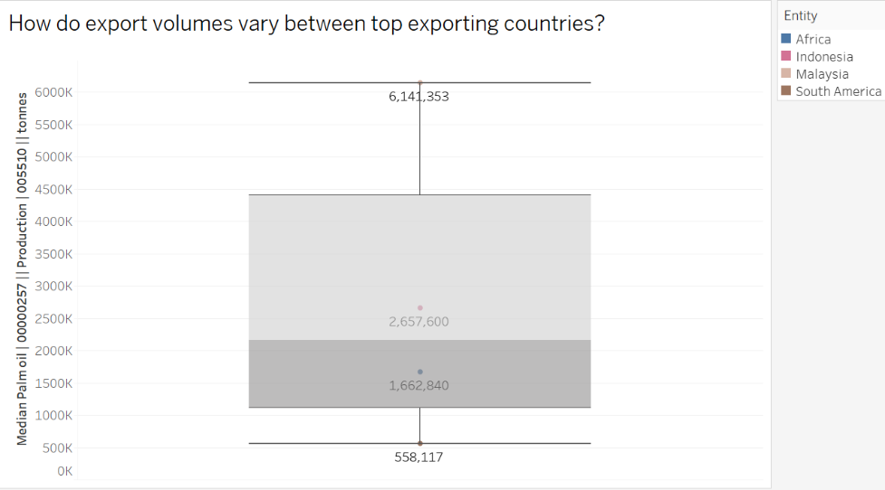

Overview of the dataset:
Chart Type: Box and whiskers plot
Fields Used: Country, Palm oil | 00000257 || Production | 005510 || tonnes
Colour Encoding: Each country is represented by one unique colour

Insights:
From this visualization, we can infer that Indonesia has the highest median palm oil production, with it’s median production being around 6,141,353 tonnes, significantly exceeding the other regions. This indicates that Indonesia is the top producer and exporter of palm oil. Following that, Malaysia and South America have a similar range of production values, with Malaysia having a slightly higher median of 2,657,600 tonnes and South America’s median being 1,662,840 tonnes. Lastly, Africa has the lowest median production value out of all the top exporting countries, indicating that its palm oil production is significantly lower compared to the other regions, with 558,117 tonnes of palm oil being produced.

How it helps SawitPRO and recommendations:
By analysing how export volumes vary between top exporting countries, the visualization confirms that Indonesia has the highest median palm oil production, significantly outpacing other regions. This solidifies Indonesia's role as a global leader in the palm oil industry, aligning with SawitPRO's home-base advantage. It validates SawitPRO's focus on optimizing operations, enhancing sustainability, and supporting stakeholders in Indonesia to maintain and grow its leadership position in the global market. Following that, this visualization also compares Indonesia's production with other major exporters like Malaysia and South America provides a benchmark for performance. SawitPRO can then use this information to analyze why Indonesia has a higher production capacity and help its stakeholders replicate successful practices to maintain competitiveness.

- What are the peak years for palm oil exports for palm oil exports in major markets?

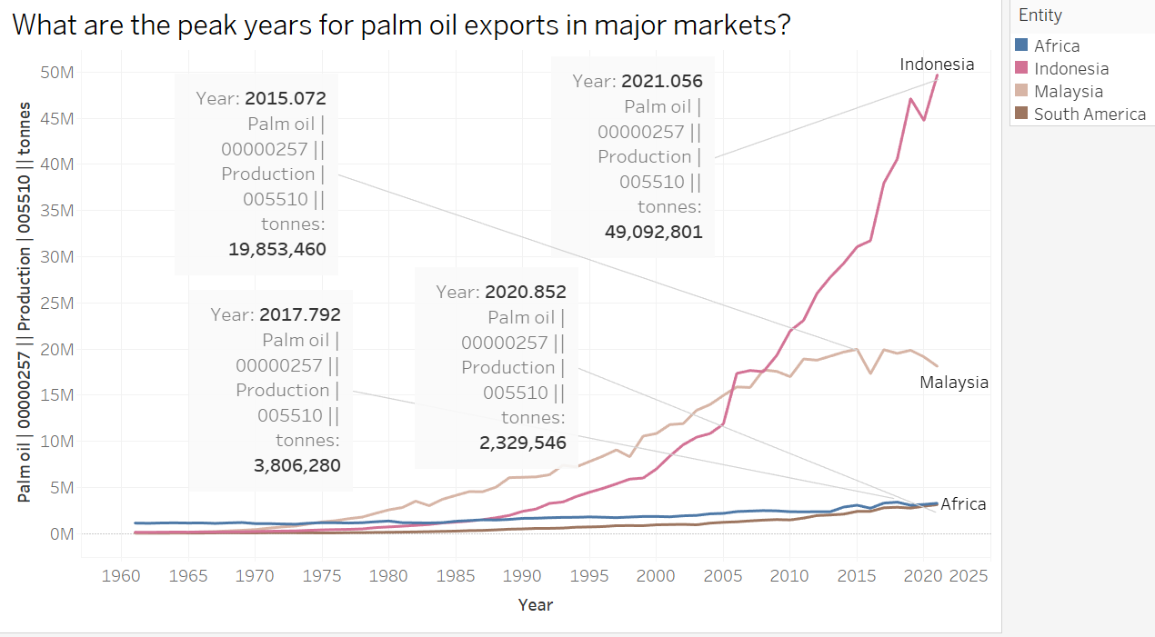

Overview of the dataset:
Chart Type: Line chart
Fields Used: Country, Year, Palm oil | 00000257 || Production | 005510 || tonnes
Colour Encoding: Each country is represented by one unique colour

Insights:
From this visualization, we can infer that the peak years of palm oil production for Indonesia (leading producer), Malaysia, Africa and South America are 2021, 2015, 2017 and 2020 respectively.

How it helps SawitPRO and recommendations:
By analysing the peak years for palm oil exports for palm oil exports in major markets, SawitPro can forecast revenue more accurately In 2021, Indonesia produced 49,092,821 tonnes alone that year, which was in line with an increase in biofuel production largely due to the implementation and expansion of biodiesel blending mandates, such as the B30 program (30% palm oil blend in diesel fuel). This initiative has made Indonesia the largest producer and consumer of palm oil-derived biodiesel globally. In 2020, South America produced 2,878,884 tonnes alone that year which was the most it has produced as shown in the visual due to Governments in South America implementing policies to promote biofuel production and sustainability in agriculture. For instance, Colombia has made significant strides in producing certified sustainable palm oil (CSPO), reaching 28% of its total production in 2020. In 2017,Africa produced 3,806,280 tonnes of palm oil in that year, which was the most it has produced as shown in the visual. This was attributed to a renewed interest in expanding oil palm plantations during this period, particularly in countries like Ghana, Nigeria, and Gabon. This was driven by the increasing global demand for palm oil and efforts to capitalize on available arable land. Moreover, many African nations began to embrace large-scale commercial cultivation alongside traditional smallholder farming, boosting production levels​. Lastly, in 2015, Malaysia produced 19,853,460 tonnes of palm oil in that year which was the most it has produced as shown in the visual. This is due to the combination of strong export demand and an increase in domestic production. Malaysia benefited from importing processed palm oil (PPO) from Indonesia due to lower export levies imposed on Indonesian PPO compared to crude palm oil (CPO). This facilitated local processing, which added value and boosted export volumes. Additionally, palm oil stocks were high in 2015, supported by increased production and imports. This led to Malaysia meeting export demands efficiently. Favorable weather conditions may also have contributed to higher yields, although fluctuations in global oilseed markets and crude oil prices influenced the sector. The market conditions in 2015 allowed Malaysia to optimize its production and trade, achieving peak output​. Therefore, by learning what the main drivers for palm oil in major markets are, SawitPRO can anticipate high-demand years and adjust their operations accordingly, ensuring that they can take advantage of price increases during peak export periods.

- What is the production of different vegetable oils in major export regions?

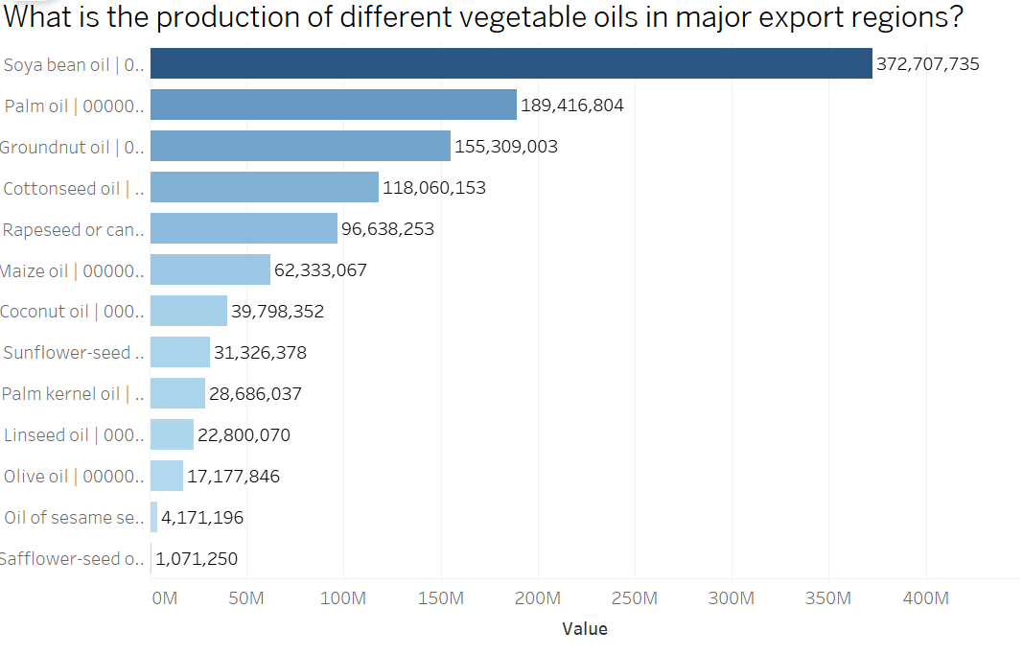

Overview of the dataset:
Chart Type: Bar chart
Fields Used: Country, Soya bean oil | 00000237 || Production | 005510 || Tonnes, Palm oil | 00000257 || Production | 005510 || tonnes, Groundnut oil | 00000244 || Production | 005510 || tonnes, Cottonseed oil | 00000331 || Production | 005510 || tonnes, Rapeseed or canola oil, crude | 00000271 || Production | 005510 || Tonnes, Maize oil | 00000060 || Production | 005510 || tonnes, Coconut oil | 00000252 || Production | 005510 || tonnes, Sunflower-seed oil, crude | 00000268 || Production | 005510 || Tonnes, Palm kernel oil | 00000258 || Production | 005510 || tonnes, Linseed oil | 00000334 || Production | 005510 || tonnes, Olive oil | 00000261 || Production | 005510 || tonnes, Oil of sesame seed | 00000290 || Production | 005510 || Tonnes, Safflower-seed oil, crude | 00000281 || Production | 005510 || Tonnes
Colour Encoding: Each country is represented by one unique colour.

Insights:
From this visualization, we can infer that Soy Bean Oil is the most popular vegetable oil exported by major export regions, with 373,707,735 tonnes being exported, followed by palm oil being the second most popular vegetable oil exported by major export regions, with 189,416,804 tonnes being exported, approximately half the amount of soy bean oil exported.

How it helps SawitPRO and recommendations:
By analysing the production of different vegetable oils in major export regions, SawitPRO can look to expand it’s business offerings to soy bean oil as well to diversify its product offerings. Soybean oil, as one of the most widely exported vegetable oils globally (373,707,735 tonnes), presents a significant opportunity for SawitPro to diversify its product range. By expanding into soybean oil, SawitPro can tap into markets that prefer this oil, especially in regions like North America and parts of Asia, where soybean oil is a primary cooking oil and industrial ingredient​. Furthermore, SawitPRO can also cater to different consumer preferences through the expansion of product offerings with soy bean oil. Different markets have different preferences for vegetable oils. While palm oil is widely used in food production, cosmetics, and biofuels, soybean oil is favored for its neutral flavor and health benefits, particularly in markets focused on heart-healthy products. Expanding into soybean oil can position SawitPro as a more versatile supplier, catering to varying customer needs across different regions, resulting in an expanded revenue streams. Soybean oil, as a highly demanded product globally, provides an opportunity for SawitPro to enter new markets and grow its share in existing markets. This expansion will likely lead to increased profitability, benefiting those with a financial stake in the company, benefitting both the company and stakeholders (etc investors).

- Which countries are the largest producers of biofuel, and how does their palm oil production compare?

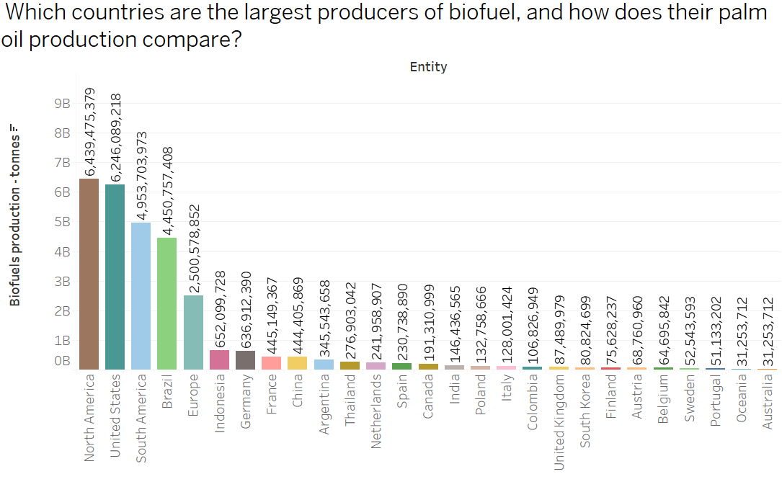

Overview of the dataset:
Chart Type: Bar chart
Fields Used: Country, Biofuel Production/tonnes
Colour Encoding: Each country is represented by one unique colour.

Insights:
From this visualization, we can infer that countries with high palm oil production, like Indonesia, are likely to be part of significant contributors to global biofuel production. Indonesia, the leading producer in palm oil, also happens to be the 6th highest in terms of biofuel production, with 652,099,728 tonnes being produced. Other high palm oil production countries like South America, ranks 3rd highest in terms of biofuel production, with 4,953,703,973 tonnes being produced. Lastly, North America, which ranks highest in terms of biofuel production, with 6,439,475,379 tonnes being produced, is also one of the leading palm oil producers in the world according to the leading palm oil producers visualization. This shows that some leading palm oil producers are also leading biofuel producers.

How it helps SawitPRO and recommendations:
By analysing which countries are the largest producers of biofuel, and how does their palm oil production compare, SawitPRO can consider integrating palm oil production with biofuel supply chains. Since some of the largest biofuel producers are also major palm oil producers, SawitPRO can take this opportunity to expand its product offerings into biofuels. Since palm oil is a key feedstock for biodiesel production, SawitPro could potentially increase its market share in the biofuel industry by aligning with global biofuel production trendswith Industry Trends. Biofuels are gaining attention as part of global sustainability and clean energy efforts. By understanding the biofuel production landscape, SawitPro can strategically position its palm oil as a key ingredient in biofuels, catering to markets that are increasingly demanding renewable energy solutions. This can attract new customers, especially those involved in the energy sector. This diversification into biofuels can help generate additional revenue streams, reducing reliance on the fluctuating prices of palm oil. For stakeholders like investors and shareholders, this presents a lower-risk business model with a steady growth trajectory, especially as demand for renewable energy increases globally access to Emerging Markets. By aligning with biofuel trends, SawitPro can then expand into these emerging markets, increasing sales and profitability, which benefits stakeholders who are invested in the company's long-term growth.

- How does biofuel production influence the export volumes of palm oil in major palm oil producing countries?

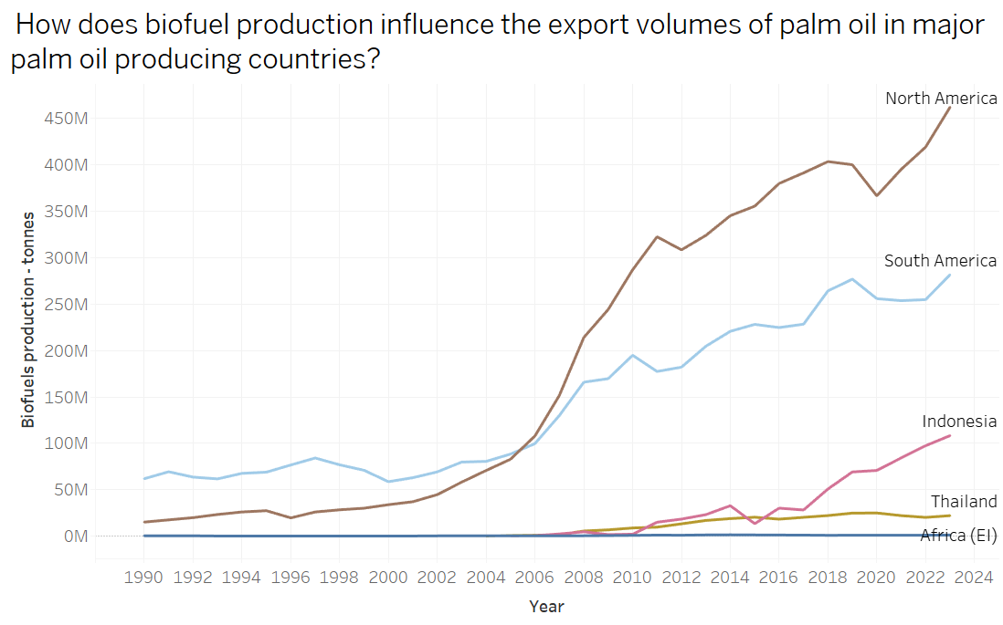
Overview of the dataset:
Chart Type: Line chart
Fields Used: Country, Year, Biofuel Production/tonnes
Colour Encoding: Each country is represented by one unique colour.

Insights:
From this visualization, we can infer that hile biofuel production has been on a steady rise, particularly in North America, South America and Indonesia, the trends for other high palm oil-producing countries like Thailand, and Africa (EI) are more nuanced. From this visualization, North America is the leading producer in Biofuels, showcasing a continuous increase of approximately 370M to approximately 460M from 2020-2023. Similarly, Indonesia also shows a continuous increase of approximately 70M to approximately 110M from 2020-2023, during the same years.
How it helps SawitPRO and recommendations:

By analysing how does biofuel production influence the export volumes of palm oil in major palm oil-producing countries, understand how biofuel production influences palm oil export volumes in major producing countries provides valuable insights for SawitPRO and its stakeholders in terms of market dynamics, resource allocation, and strategic planning. Although we can somewhat correlate the increase in the production of palm oil during the same years with the increase in production of biofuel for countries like Indonesia, countries such as North and South America have not much co relation. For example, we can attribute Indonesia’s growth in biofuels to be driven by increase production in palm oil, which was in line with an increase in biofuel production largely due to the implementation and expansion of biodiesel blending mandates, such as the B30 program (30% palm oil blend in diesel fuel). However, North America’s and South America’s increase in biofuels is largely due to the rise of biofuel production from sources like corn, sugarcane, and soybean which provided alternative sources of renewable energy, potentially reducing the demand for palm oil-based biofuels. Therefore, this shows that biofuel production influence is not necessarily related to the export volumes of palm oil in major palm oil-producing countries. For SawitPRO, this insight allows the company to align its operations with emerging trends, such as targeting markets with rising biofuel demand. It also helps stakeholders, including mills, smallholders, and agents, understand the potential influence of biofuel mandates on palm oil pricing, demand, and export strategies. Additionally, the nuanced trends in regions like Thailand and Africa may indicate opportunities to optimize or diversify operations to meet specific local or global biofuel requirements. By leveraging these insights, SawitPRO can position itself as a key player in the evolving biofuel-palm oil nexus, ensuring sustainable growth and profitability for its stakeholders.

- Dashboards

- Sales Performance Dashboard

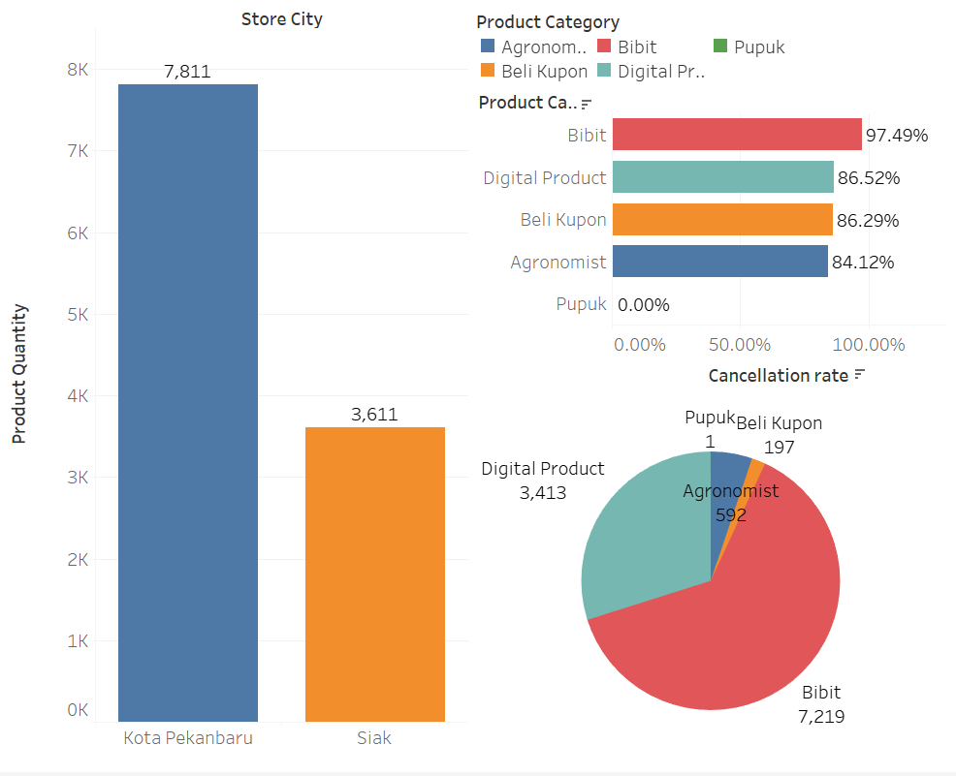

This dashboard comprises of the three exploratory questions, what is the total number of products sold for each product category, what is the order cancellation rate by product category and which city store city has the lower sales volume. This dashboard mainly focuses on sales performance by identifying top and under-performing product categories and underperforming cities, highlighting where cancellations are high and where sales volumes are low, potentially indicating operational or customer satisfaction issues.

- User Activity Dashboard

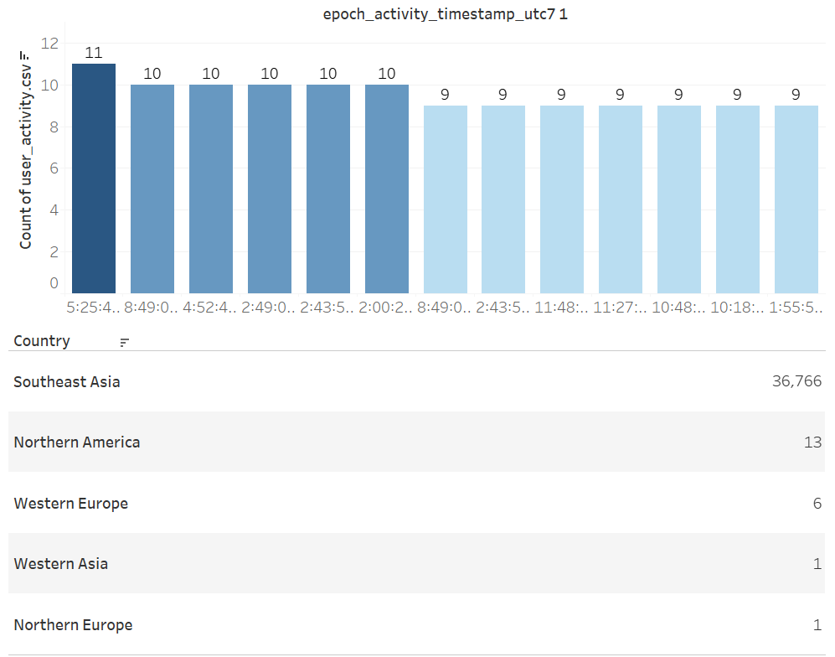

This dashboard comprises of two exploratory questions, what is the distribution of user activity across different regions and which time of the day (UTC +7) has the highest user activity. This dashboard mainly focuses on user activity where the highest user engagement occurs, optimize marketing efforts in these regions and optimizes operational hours based on peak user activity to better engage users at critical times.

- Palm oil export analysis dashboard

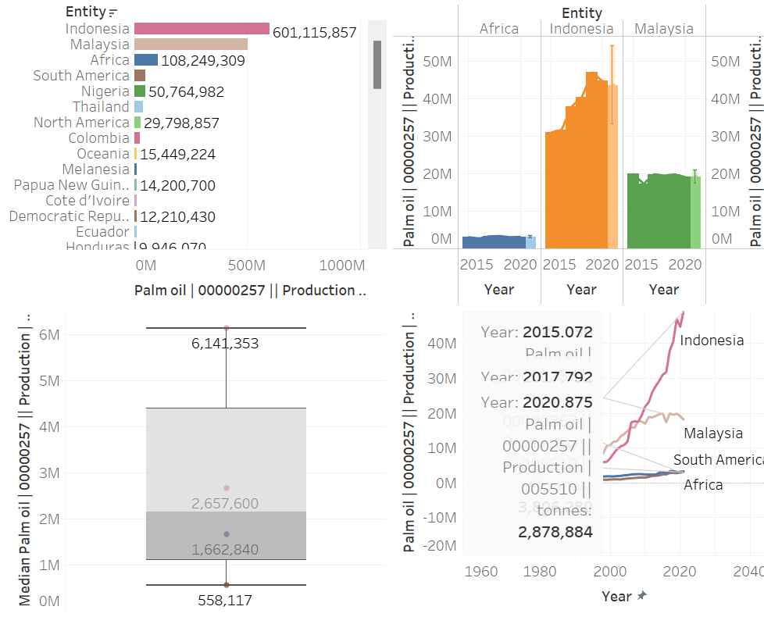

This dashboard comprises four exploratory questions, what is the country with the highest palm oil production, how have countries with the largest palm oil export volume changed over time, how do export volumes vary between top exporting countries, what are the peak years for palm oil exports in major markets. This dashboard identified trends in export volumes over time, highlighting peak export years and informing production planning for SawitPro, determining which countries are the largest producers and exporters of palm oil, helping SawitPro understand the competitive landscape.

- Product expansion dashboard:

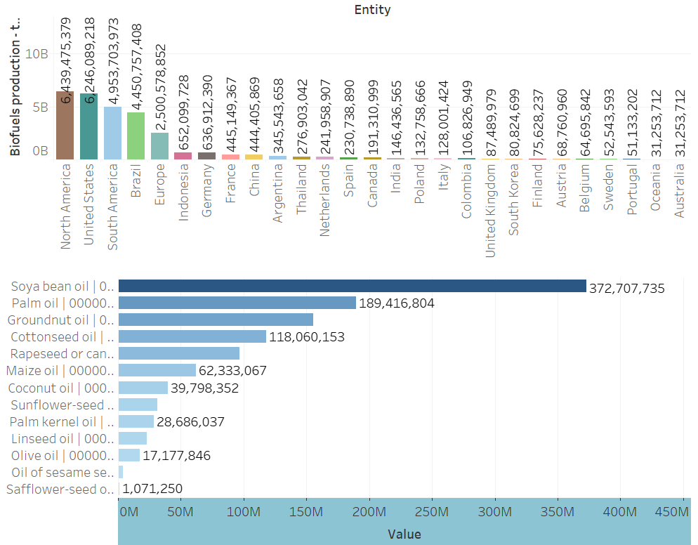

This dashboard comprises two exploratory questions, which countries are the largest producers of biofuel, and how does their palm oil production compare and what is the production of different vegetable oils in major export regions. This dashboard identifies opportunities for SawitPro to integrate biofuel production with its palm oil supply chain as well as potentially expand its product offerings with soybean oil instead of just palm oil alone, which can help SawitPRO explore new product offerings and tap into new markets.

- Conclusion

In conclusion, this assignment highlights how crucial data exploration and visualization are to producing useful insights for corporate decision-making. I have discovered patterns, correlations, and trends by using Tableau Desktop to analyze the provided datasets. These will aid SawitPRO in streamlining its processes and growing its clientele. The landscape of the palm oil business is better understood because to the insights gleaned by examining these datasets. In addition to providing answers to important exploratory questions, these visualizations will assist SawitPRO stakeholders in making well-informed decisions regarding operational enhancements, market strategies, and possible growth prospects. The project's experience highlights the importance of data storytelling and how it propels company expansion and sustainability in the Agritech industry.

